1.0 Ignition Timing Objectives Summary
1.1 Overview of Mechanical Events
1.2 Timing Curve – Layering into Regions and Points
1.3 Tuning Analysis Categories
1.3.1 Minor Timing Regions
1.3.2 Transitional Timing Region
1.3.3 Crucial Performance Regions
1.4 Analysis Process
1.4.1 Minor Timing Region Analysis
1.4.2 Performance Analysis preparation
1.4.3 Performance Analysis
1.4.4 Final Curve Generation

2.0 Combustion and Detonation
2.1 Principals of Combustion
2.2 Principals of Detonation
2.3 Detecting Detonation
2.3.1 Visual detection
2.3.2 Cylinder Head Temperature Measurement
2.3.3 Electronic Detonation Devices

1.0 Ignition Timing Objectives Summary

Optimization of the ignition timing is to result in maximum torque throughout a given RPM range. It’s easy to get close, but to really extract the best results takes an understanding of the various events and side effects.

Part of the RPM range requires enough spark advance to run on the edge of detonation of a high compression motor. Detonation results in damage to the components of the motor from erosion and pitting of the materials in contact with the combustion media, to bearings and other reciprocating components. Part of the RPM range requires retarding the ignition to alter the temperatures of the exhaust, resulting in adding over-rev. At any point in between, other chaotic events may occur such as a harmonic reed flutter that may invite a retarding or advancing action for very short intervals.

The SPI system has been designed to provide the most accurate control of timing available. Together with the intuitive programming option, you can finely tune additional power out of your motor without risking detonation damage if you have a good understanding of the ignition events to work around and how to detect detonation.

1.1 Overview of Mechanical Events

Port timing and pipes are designed to accommodate a high power peak across a narrow range of RPM. There are various known events that will determine the basic layout of the ignition timing profile. There are also various chaotic or unknown events that will need to be factored that this guide will identify. For the purposes of this example, we will look at a motor tuned to operate between 8800 and 12,000 RPM with a flat line ignition, and a torque peak of 10,500 RPM.

As the cycle time changes with RPM, the events of port timing and pipe design change in sequential order. The pipe design has a huge impact on 2 stroke power, and the ignition timing can be used to compensate for the changes somewhat. By dialing more retard in at higher RPM, more heat is passed to the exhaust, and higher temps simulate a shorter pipe. This works as the speed of sound (the key factor in the acoustical characteristics of the pipe) increases with higher temperature. Balancing the added heat in the pipe with the loss of efficiency of a later spark can result in extending the usable RPM range – overrev – by over 500 RPM.

There are certain chaotic events that may occur at any given RPM. Typically some reeds have a harmonic bounce that may occur at say 10,200 – 10,250 RPM, resulting in a richer mixture. A little steeper advance may offset this problem. A pipe may have a resonant point at 10,850-10,950 RPM that requires a slight retard across this range.

1.2 Timing Curve – Layering into Regions and Points

Viewed graphically a timing curve is a set of points that is broken down into operational layers of evaluation. At the first layer are the Regions that determine the major functions of the motor. Minor Timing Regions are not a significant subject of performance and are more of a convenience for tuning.

As the Regions can be broken down into points of 100 RPM increments, a second layer of analysis is at this finer increment. To manage development of the best curve takes a layered approach to defining regions for the curve.

The first layer can be defined around the 5 major predictable ignition regions in RPM operations ranges.
- Cranking Velocity
- Idle Velocity
- Ramping Velocity
- Critical Path
- Overrev

The second layer takes any of these Regions and can allow further breakdown to programmable RPM increment every 100 RPM.

1.3 Tuning Analysis Categories

Each of the five Regions best fits into a category of functional operation to understand isolate these operations for analysis.

Minor Timing Regions include the Regions that are not on track performance related.

Transitional Timing Region is where the curve will have some effect on starts and at the lower RPM side of the most important performance Regions.

Crucial Performance Regions are the areas with the most emphasis and return in performance.

1.3.1 Minor Timing Regions

Cranking Velocity Region - to keep the motor from kicking back the cranking speed timing should only be advanced 3-5° Cranking speed is defined as starting at 0 RPM, and can extend to 1200-2500 RPM. Not much to be gained here over the standard setting. The cranking region is modified to allow a motor to start on the stand without kickback, generally 3° - 6° advance BTDC is all that is necessary. The higher the compression, the less advance necessary is a general rule.

Idle Velocity Region can range from 1200 RPM to 1600 RPM. The ideal is to keep the same advance setting from 0-2500 RPM to avoid large fluctuations of idle speed at the first advance point. Some set ups may favor a small (1-5°) timing advance between Cranking (<600 RPM) and Idle Speed (>900 RPM) to enable a consistent idle through warm up.

1.3.2 Transitional Timing Region

Ramping Velocity Region – a range from idle speed plus 300 RPM (>1900 RPM) to roughly 75% of the peak torque RPM. If the motor makes peak torque at 10500, this is about 7875 RPM. The crucial part of the performance in the Ramping Velocity is on the start and defining the bottom operating range of RPM during race conditions and is considered a Transitional Timing Region.

Generally the timing slope of the Critical Path Region is flat in an ideal world. The transition point is that RPM value where this slope begins. Figure 1 shows this slope beginning at 7700 RPM, but this will be unique to your setup. The SPI programs are designed to provide a starting point in identifying a baseline for this transition RPM, but every setup can differ. Various Port Timing values and Pipe Designs will play an important role in finding the optimum Transitional RPM.

1.3.3 Crucial Performance Regions

Critical Path Region – a range from roughly 75% to 110% of the Peak Torque RPM. If the motor makes peak torque at 10,500 RPM, this would be roughly 7875-11,550 RPM. Again the Port Timing values and Pipe Design will affect the specific value, but this is a pretty close baseline for most shifter motors. Generally the resulting timing curve is a flat slope between these points, although there can be variations to where optimization is found.

Pipe Design can play a role in these deviations, due to:
- Varying convergence cone wall angles – Steeper angles will produce higher reverse pressures at the RPM where the length is tuned to have the most effect.
- Tuned Lengths of Pipe Elements – this includes shimming pipes, stinger lengths, and various silencers.

Other aberrations can exist, harmonic reed flutter, and carburetion flat spots among them. There are too many things to predict the behaviors of. In most cases these aberrations are short-lived occurring over 100-200 RPM range. If these aberrations favor a little more advance for 100-200 RPM, it is generally not worth much at all on the track. The important part is when these aberrations invite detonation, and may force the tuner to back off advance through the entire Critical Path Range.

Overrev – a range over 110% of the Torque Peak RPM. Most MX Ignition systems are designed to encourage the rider to shift at a lower RPM then the motor is capable of and they accomplish that by advancing the ignition. This advance will more quickly bring the pipe to the “end of the punch” it is designed for.

Sustaining a retard beyond the Critical Path Region will extend the usable power range over a flat line or OEM MX power curve by a good margin. This can enable a lower gear ratio and provides a wider power band with no loss of peak torque.

In many cases the slope of the Overrev Region is very similar to that of the Critical Path Region; however there are no concerns of detonation in this region.

WARNING - Extending overrev will result in higher EGT temperatures. In some setups, this will be tolerable, but not all cases. YOU WILL need to establish your own standards of upper limit EGT safety if you rely on these measurements for jetting.

1.4 Analysis Process

The SPI unit comes with 4 baseline curves already programmed in the unit, and the software contains the composition for each of these curves. Curve A provides an excellent general baseline that should be safe to use.

WARNING – the curves provided are baselines and depending on your setup may exhibit detonation even with the mildest curve. For example, the CR125 curves are developed using an RLV B4 pipe with less then 9.5cc Chamber measurement (including spark plug threads). This may work fine with this setup, but other pipes or more compression could cause detonation to occur.

Figure 1 illustrates a typical ignition curve where you can see the 5 Regions. Note the slope beginning at the transition to the Critical Path to max overrev is relatively flat.

Figure 1, SPI Ignition Curve Graph
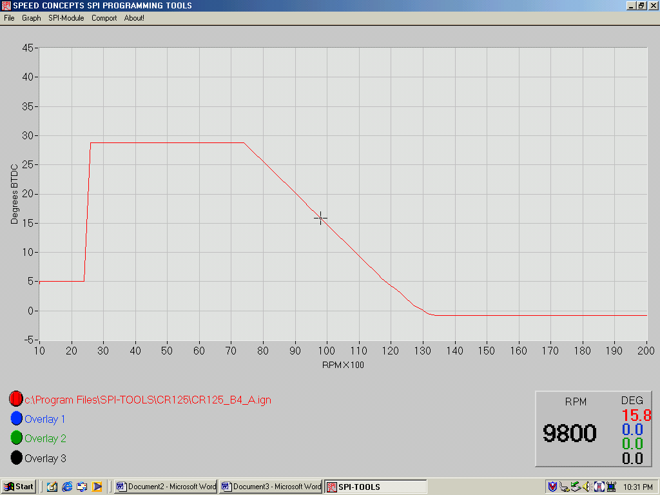

Each of these Regions can be fine tuned though trial and error to identify the limits. Typically each of the four curves provided with the unit progressively adds slightly more advance at the Critical Path Region beginning above 7500 RPM.

As a reminder, the static timing of the stator should be set to the center position per the Installation Instructions.

WARNING - Before experimenting with advanced ignition curves, you should be familiar with what detonation is, what damage it can do to the motor, and how to identify detonation. This is covered in detail in Section 2.

1.4.1 Minor Timing Region Analysis

With a high compression motor is hard to crank in first gear. If the motor kicks back excessively, you may want to retard the timing a few degrees at a time down to as low as 0°. Retarding the ignition too far will result in starting difficulty and popping in the pipe. Baseline settings should work fine for 95% of all setups.

Idling characteristics are affected by the timing, and it is preferred that the timing does not change throughout the idling range of RPM. This will allow you to tune the idle through the carburetor without fluctuations caused by changing timing. It is recommended to maintain flat line timing from cranking through the idle speed. Again, Baseline settings should work fine for 95% of all setups.

1.4.2 Performance Analysis preparation

You may use a track or dynamometer to test the curves with. It should be noted that track testing will provide the most realistic of results, and that while Dyno testing is very useful, it is not required. Curves should always be kept in the order of advance aggressiveness, “A” the least, and “D” the most aggressive.

You will want to have a handful (5+) of clean and gapped sparkplugs that do not have prior evidence of detonation.

A pencil beam flashlight to inspect the piston through the sparkplug hole is needed.

A 10X Magnifier to inspect spark plug for detonation speckles.

Recommend a used piston, but still in good condition.

1) Prepare a log sheet of your setup with the data shown in Table 1.

2) Evaluate the four curves provided by opening the SPI Tools application, and loading the curves programmed in the box.
- Red Curve as Curve A
- Blue Curve as Curve B
- Green Curve as Curve C
- Black Curve as Curve D

3) Fill with Fresh Fuel/Oil mix. Stale fuel will detonate much more readily.

4) Running the “A” curve, make sure Jetting is correct with a few minutes of operation at full operating temperature.

5) Inspect Spark Plug for evidence of detonation.

Testing may now begin.

1.4.3 Performance Analysis

Table 1 Test Data
Parameter | Run 1 | Run 2 | Run 3 | Run 4
Fuel type | B32 | B32 | B32 | B32
Oil Ratio | 28:1 | 28:1 | 28:1 | 28:1
Ambient Temp | 64° | 66° | 66° | 66°
Humidity | 87% | 84% | 83% | 84%
Air Pressure | 29.88 | 29.81 | 29.90 | 29.81
Curve Name | A – file 1 | B – file 2 | B– file 2 | B – file 2
Jet | 168 | 168 | 168 | 168
Plug | BR10 | BR10 | BR10 | BR10
Squish | .029 | .029 | .029 | .029
Head CC | 9.2 | 9.2 | 9.2 | 9.2
Pipe | RCE T5 | RCE T5 | RCE T5 | RCE T5
Exhaust Duration | 195° | 195° | 195° | 195°
Laptimes*
DynoSheet | Baseline | Better | NA | NA
Post inspection
Spark Plug | OK | Speckles | OK | Speckles
Piston | OK | OK | OK | OK
Notes |  |  | Maintained 7800 – 10000 RPM | Maintained 7800 – 10200 RPM

Comparing the runs above, Run 1 with Curve A was OK. Run 2 Curve B showed a little more bottom end grunt on the dyno sheet from 7800-9800 RPM, but also showed traces of detonation on the Sparkplug. The piston was still OK in visual inspection through the Sparkplug hole. Run 3 was operated with a limit of 10,000 RPM, and no detonation. Run 4 was conducted with a ceiling of 200 RPM higher, and detonation occurred.

Logical deduction that the Detonation is occurring just above 10,000 RPM. Curves C and D are very similar having the transition edge extended. Let’s repeat the test running curves C and D keeping the RPM below 10,000.

Table 2 Test Data
Parameter | Run 1 | Run 2 | Run 3 | Run 4
Fuel type | B32 | B32
Oil Ratio | 28:1 | 28:1
Ambient Temp | 67° | 67°
Humidity | 81% | 81%
Air Pressure | 29.88 | 29.81
Curve Name | C – file 3 | D – file 4
Jet | 168 | 168
Plug | BR10 | BR10
Squish | .029 | .029
Head CC | 9.2 | 9.2
Pipe | RCE T5 | RCE T5
Exhaust Duration | 195° | 195°
Laptimes*
DynoSheet | Best | Worse
Post inspection
Spark Plug | OK | Speckles
Piston | OK | OK
Notes | Maintained 7800 – 10000 RPM | Maintained 7800 – 10000 RPM
We learned that up to 10,000 RPM, the C Curve worked best.
10,000 – 10200 the B curve worked best.

This is where a Programmer comes in handy. We now prepare four new curves.
- New curve “A” that has the characteristics of “C” below 10,000, the characteristics of “B” from 10,000 – 10,200, and the characteristics of “A” over 10,200.
- New curve “B” that has the characteristics of “C” below 10,000, the characteristics of “B” over 10,200.
- New curve “C” that has the characteristics of “C” below 10,000, the characteristics of “B” from 10,000- 10,500, and the characteristics of “C” over 10500.
- New curve “D” that has the characteristics of “C” below 10,000, the characteristics of “B” from 10,000- 10,200, and the characteristics of “C” over 10200.

In effect, what we are doing through trial and error we keep throwing a little more advance until we see detonation and then back off. The Dyno or the track will continue to favor running on the edge of detonation, but you should always build yourself in a little cushion of safety. The difference between a the ragged edge and a safe cushion of about 1-1.5° backed off is less then a tenth of a second at any sprint track.

Up to about 110% of the peak torque RPM, we are building in as much advance as we can. With most highly tuned shifter kart motors, 110% is where the sonic waves in the pipe cannot keep up with the velocity of the motor. This percentage will vary more to the plus side depending on the Porting and Pipe. When this point is reached, the gains from advancing the timing are offset by the loss of sonic efficiency in the pipe.

By letting the combustion take place just a little later allows more heat to escape to the pipe, and in turn raises the velocity of the sonic waves. In most (but not all) cases we are looking for slight increase in the slope angle over the last 300-500 RPM of the full operating limit now extended with overrev.

Overrev analysis is best performed on the track. Once you achieve a satisfactory power curve, experimentation with the overrev can be tailored by programming curves with deviations to the bottom of the slope. Note where the shift points are before and after as this will provide a good reference to where the timing needs to be set. Also try a few runs topping out in 5th gear to see where the motor pulls to.

1.4.4 Final Curve Generation

Looking at the ambient conditions of the test and the anticipated conditions of race day(s) can help decide the composition of 4 very well suited curves. Changes in Relative Air Density (RAD) are not linear in the sense that 105% RAD is 10% greater chance of detonation then 95% RAD. Humidity has a profound effect on detonation, with a small effect on RAD for example. For every 15° warmer, you may tend to run with an added degree of advance up to overrev, and vice versa. If half of your racing is epected to be done at lower temperatures it is recommended to give yourself “two steps back” and “one step forward” to compensate for the air conditions. Typically keeping the slope about the same through the Critical path Region, with about 0.8 degrees less advance is a good general rule.

2.0 Combustion and Detonation

2.1 Principals of combustion

As the spark plug fires a flame kernel will propagate in the vicinity of the spark plug gap. Gasoline has a flash point of around 1200° F. so the kernel starts out burn growth relatively slow. Generally approximately 10% of the air-fuel within the kernel boundary takes about 90% of the time of combustion to where flashover occurs. Flashover is kind like where a critical mass of heat is achieved from two factors;

- Heat from the kernel is spread out from convection and radiation.
- Heat is generated from the further compression of the mixture -piston approaching Top Dead Center (TDC) and the expansion of the gases in the ignited kernel.

Flashover generally takes about 10% of the time of combustion, but accounts for 90% of the fuel air mass.

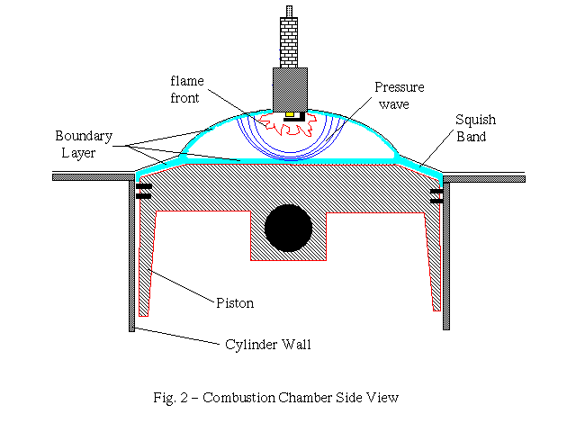

To control the flashover velocity, octane is increased. But this only goes so far, especially in a high compression engine. To achieve the maximum power flashover should occur at a point just before TDC, and all combustion should be completed at a point shortly after TDC. The later the combustion is completed after TDC, the less heat is transferred to the down stroke and lost out the exhaust. This will be important later.

Mixture ratio has a significant effect on the combustion velocity. In a perfect world, we would run about 14 parts fuel to air. We have to add oil, some of which consume oxygen at a different rate, but the biggest impact is the need to supplement some fuel for cooling purposes. Most 2 strokes run best up to a point just before sticking! We typically run 12-13:1 fuel-air ratios. The richer the mixture, the longer the kernel takes to convert to flashover. If you optimize your timing with a richer mixture (say 12:1), and then operate it at (13:1), you are inviting detonation.

2.2 Principals of Detonation
There are two forms of detonation and a third condition known as pre-ignition. For clarification pre-ignition will be explained, but it should not be considered as a programmable ignition parameter. Pre-ignition problems will be due to factors beyond a Programmable Ignition system..

Pre-Ignition is due to the kernel igniting spontaneously before the spark plug fires. High compression and hot sooty plugs are the leading contributors. It is rarely a problem with either racing fuels, or even pump fuel available today.

Premature Combustion is a form of detonation that occurs after the spark plug fires, and the combustion is completed a few degrees before TDC. This is most common among lower compression motors with a compression ratio of less than 13:1. This is also the most severe in terms of damage as it can result in cracked piston skirts, and collapsed piston domes. A motor cannot endure a significant count of premature combustion cycles, sometimes labeled hard counts.

When the flashover occurs too soon, it causes the piston to rattle as it comes to the end of the up-stroke. As the piston is traveling up to TDC, the side of the piston opposite to the center of the crank pin is most heavily loaded. As the piston begins the down stroke the side of the crank pin changes and with it the side the piston is loaded in relation to the cylinder. If there is an excess of pressure from the combustion finishing prior to reaching TDC, that thrust of force from the piston changing sides of skirt contact is often enough to cause the piston to slap a few times, leading to fractures. Premature Combustion can also lead to collapsed piston domes.

Compression Detonation is the fine edge we seem to aim for with not quite enough advance to hit it, or at least very often. This kind of detonation may also be referred to as soft counts and the typical MX motor has some limited tolerance to soft counts of detonation.

Compression detonation occurs when the secondary kernels ignite spontaneously after the primary kernel is ignited by the spark plug. With higher compression the convective heat is spread more quickly but with higher concentration to some zones then others. The higher temperature of compression coupled with the distribution effects of heat on compression is much more conducive to spontaneous ignition. The squish area has a sizable effect on distributing the heat by creating turbulence along the perimeter while keeping a large heat sink available to the trapped gasses.

These secondary spontaneous ignitions almost instantly turn to flashover. This creates multiple flame fronts that as they collide generally result in a pattern of erosion around the periphery of the piston dome, top of the cylinder, and periphery of the head. The pitting that is evident is not due to metal-to-metal contact but the turbulence and acoustic effects of the colliding flame fronts. This is also why compression detonation is more of a soft count then a hard count.

Compression detonation is also the most difficult to control and detect. Changes in air can influence compression detonation. Higher humidity lowers the incidence of compression detonation at a rate different then it affects Relative Air Density and jetting.

How much soft detonation can a motor tolerate? . Honda actually sells a detonation counter that is used by several RS racing teams, and testing has found about 80,000 counts before permanent damage takes place. If you think of a motor operating at 12,000 RPM or 200 cycles per second, this is about 6-1/2 minutes of steady state soft detonation counts.

2.3 Detecting Detonation

There are several different methods to detect detonation ranging from a sharp driver’s ear to a detonation detector and counter, with various visual inspection methods in between. These methods are given in the order of least to most protection. The summary below provides an introduction to different methods.

Summary of Detonation Detection Methods

Audible sound may be used but BEWARE – the audible sound of detonation takes both a keen and well trained ear of the driver or tuner if tested on a dynamometer. Playback of the audible difference between a normal and detonating 125 is nearly impossible to tell at CD quality. There are some tuners that prefer the audible method over others, perhaps because of the costly “music lessons” they took in learning the subtle sound of detonation.

Visual Inspection can provide a reasonable level of detection, but it will not pinpoint the RPM ranges it occurred in. Detonation damage results in pitting the surfaces of the piston dome around the outside edge, the edged of the head chamber at the edges of the squish band, and the top of the cylinder. Generally the piston shows the most evidence as the surface temperatures are hotter and more susceptible to erosion. As this metal erodes, it will leave deposits on the spark plug insulator, and this is the first thing to check. More details will be provided along with photographs of piston damage.

Cylinder Head Temperature rise can be a useful tool to determine detonation and with some practice can even indicate the RPM range it is beginning at. Using Cylinder Head Temperature mapping is an art, but can be used to identify ranges where detonation is happening.

Electronic Detonation Sensors or Counters are available and provide the best protection. Honda HRC sells a Detonation Counter kit in the $700 range. As the Honda system is a counter, it will not reveal what RPM the detonation occurred; only the number of counts between runs. The best Detonation Detection system requires an oscilloscope and a detonation sensor probe like what is used with the Honda system. Picotech makes an oscilloscope interface system that connects to a PC and can accept a Honda style detonation probe.

2.3.1 Visual Inspection Detection

Spark plug inspection can provide the first clues to detonation problems. It is crucial to be sure jetting is correct and more reliable to begin with a fresh spark plug.

The erosion process will leave tiny specs of aluminum deposited on the center electrode insulator. Specs on the sparkplug only indicate detonation is present. They do not reveal if the detonation is due to lean conditions but will leaves some traces of specks with only a 5 second burst of detonation. A spark plug check can reveal results quickly, in a qualifying mode of; yes there is detonation, or no there is not.

A ten power magnifier can be very useful to aid inspection.

Figure 2.1
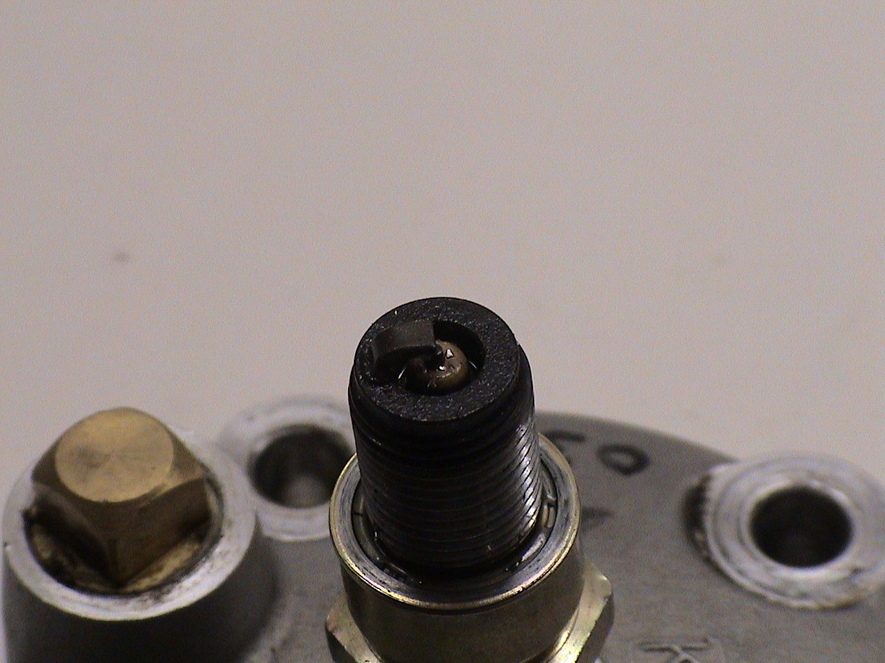

Piston dome inspection through the spark plug hole can help to reveal more about detonation. In most cases it will take 30 seconds or more of total detonation time to have a readable piston. The location of the erosion damage will indicate if the detonation is due to a lean fuel mixture or due to compression/ignition factors.

Figure 2.2  Classic Detonation  This piston suffered about 30,000 counts of soft detonation. In this case adding .002” to the base gasket eliminated the detonation. | 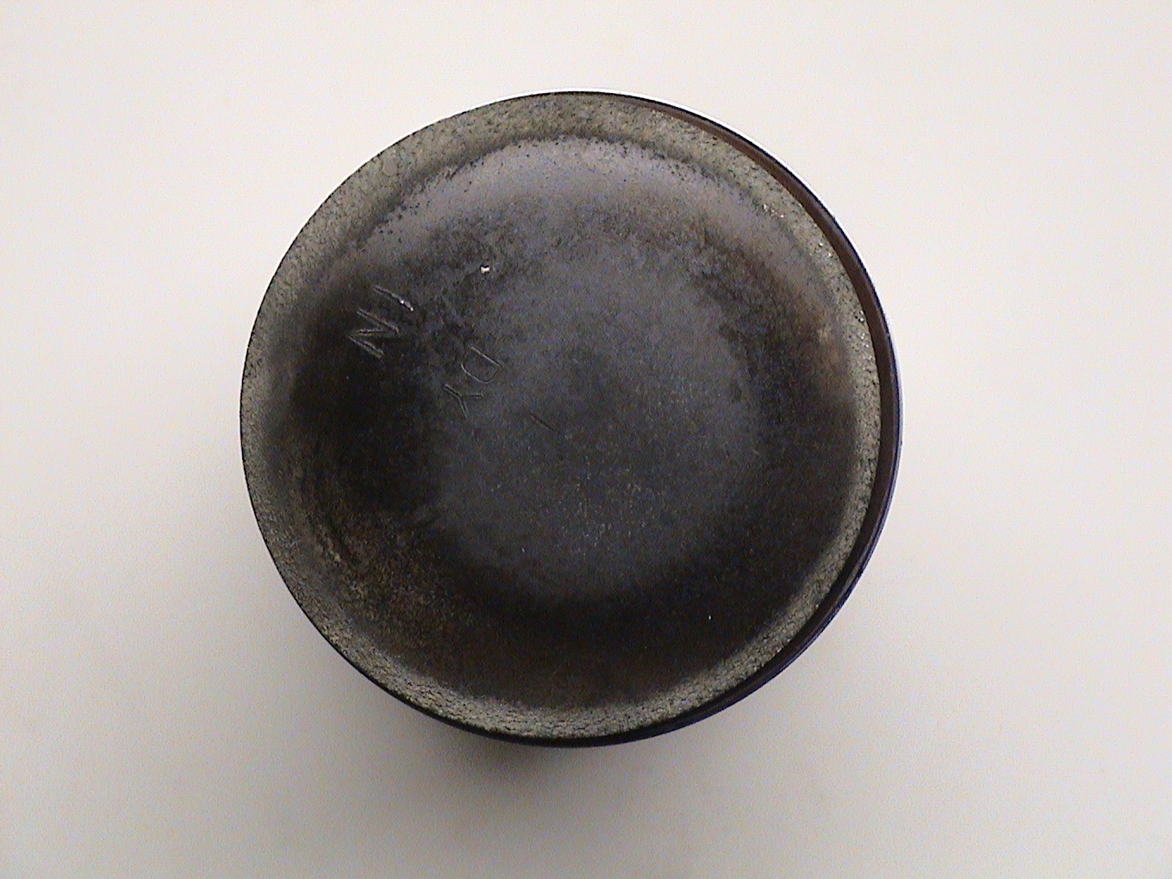

Figure 2.3  Lean Fuel-Air Detonation  This piston began to erode in the center of the dome beneath the spark plug. Once erosion begins it can lead to other catastrophic problems. | 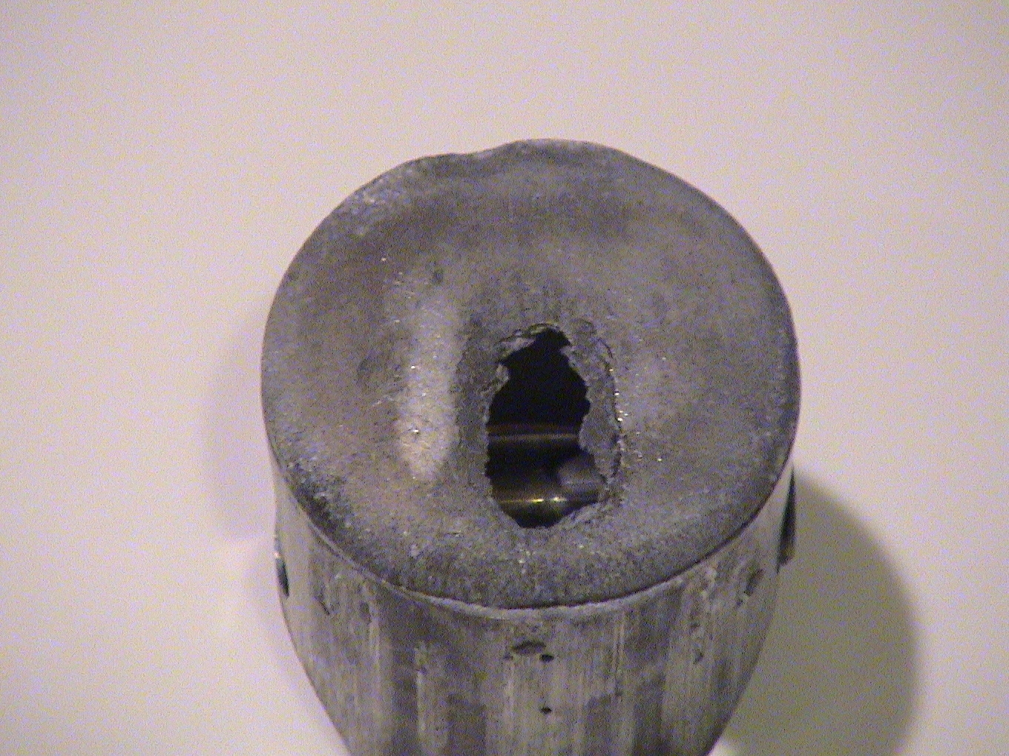

Figure 2.4  Lean Fuel – Air and  Premature Combustion  This piston lasted less then 2 laps on a road course after being broken in.  Damage to both intake and exhaust side indicates a hard rattle at TDC. Tool marks on lower edges of skirt were worn smooth. | 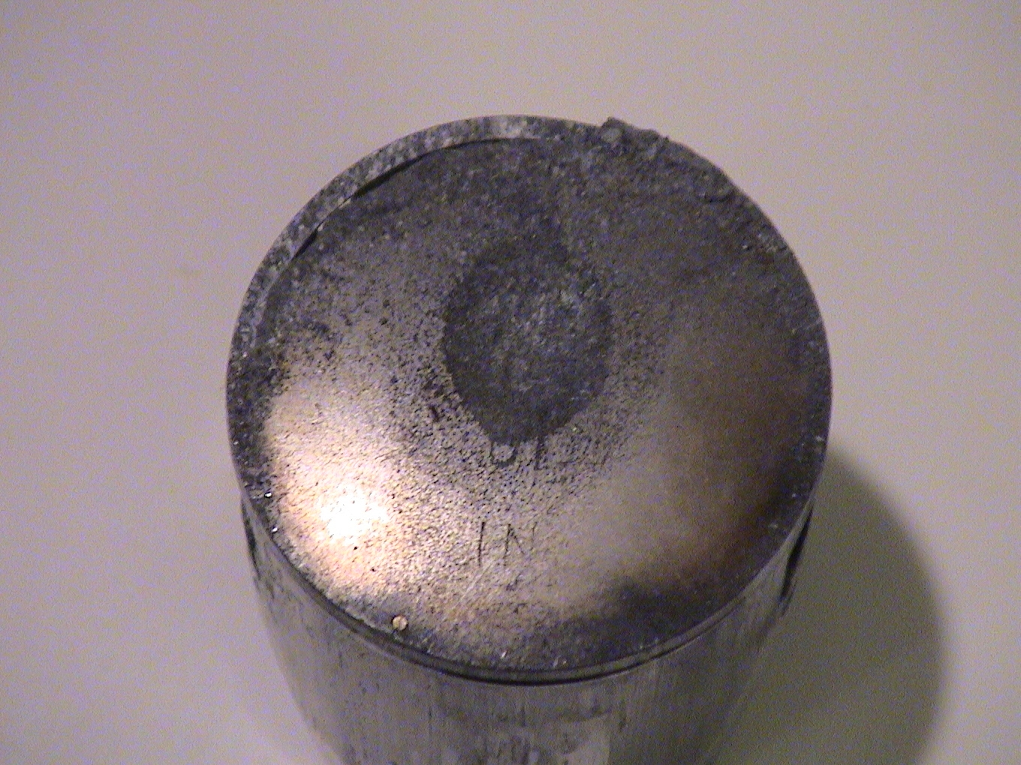  Note that this piston showed no signs of detonation when it was run with fresh 110 Octane fuel (B32). However the Track Fuel required turned out to be 98 Octane Oxygenated petrol.  Fuel is VERY important in controlling detonation!

Figure 2.5  Compression Detonation 1  This piston has evidence of light detonation. It was used exclusively to test curves created for a specific motor and has about an hour of time on it. | 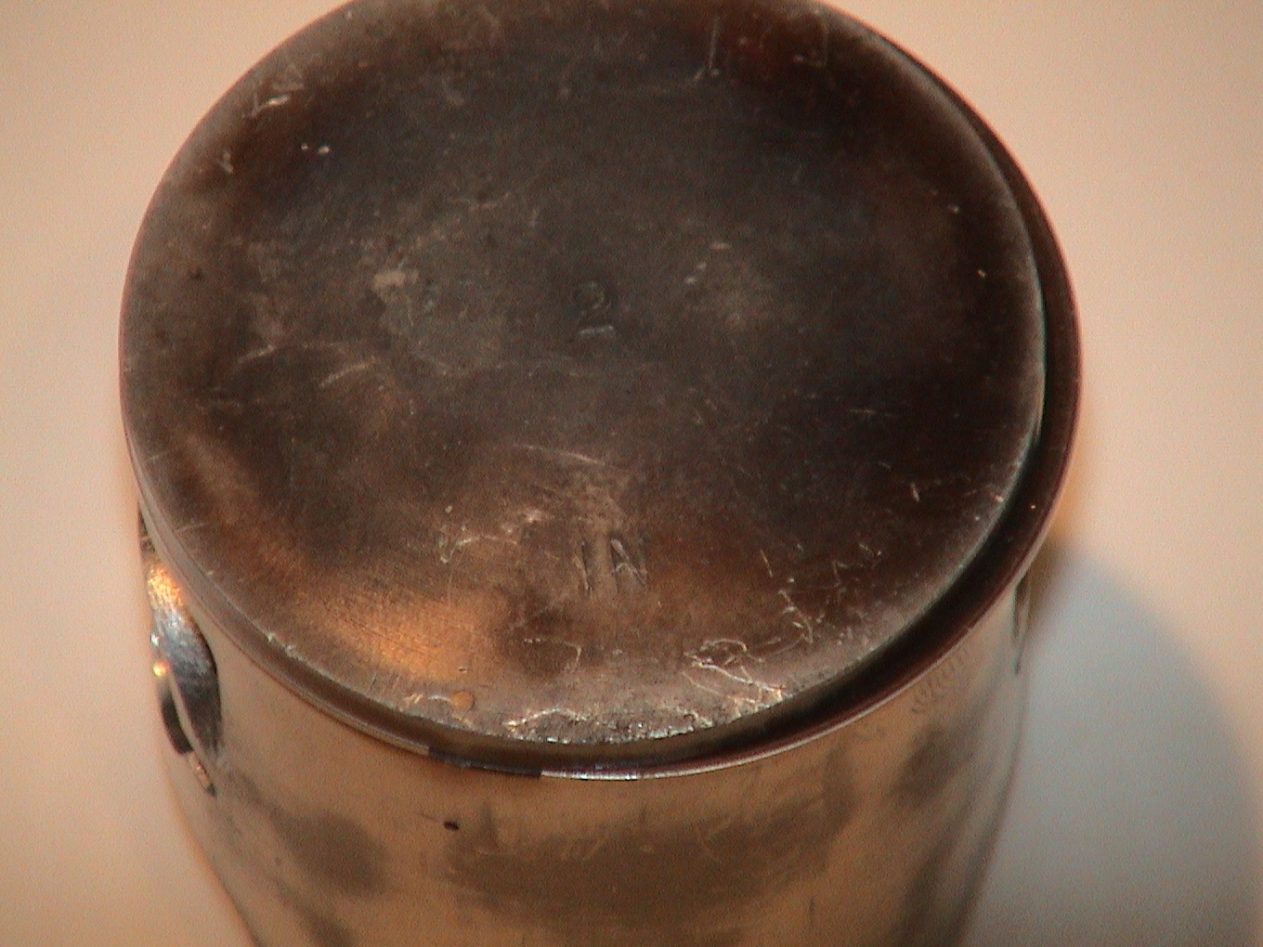

Figure 2.6  Compression Detonation 2  This piston has about two hours on it with an aggressive advance curve that proved to be too much. | 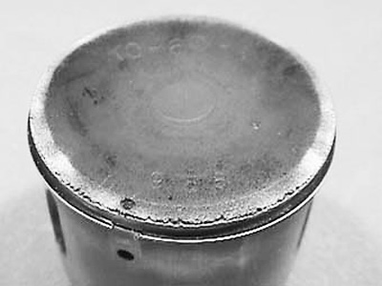

The piston is not the only place where erosion occurs. Check the outside edges of the squish band in the cylinder head, and the top .015” of cylinder bore for traces of erosion from detonation.

2.3.2 Cylinder Heat Temperature Measurement

Cylinder Head Temperature (CHT) at the Spark Plug can be a very valuable tool to help identify where detonation may be taking place. CHT will show a rapid temperature rise characteristic during detonation CHT also has some limits that must be accommodated to be of use.

When water temperature is in the 125-140° range, and the right heat range of spark plug has been selected, and jetting is correct, the CHT will typically measure about 30-40° hotter. During bursts of detonation the CHT will rise quickly, about 3-5° per second. The caveat is that CHT also has a slight delay in response, a little longer then Exhaust Gas Temperature (EGT) for example.

With a data logging system that can be downloaded to a PC like the Mychron, Alfano, or Pi system, CHT can be analyzed to see what the delay is. Wide open throttle will also see an increase in CHT over Water Temperature, but only at 1-2° per second. Replaying lap displays of Water Temp, CHT, and RPM or vehicle velocity will provide a consistent level of delay built in for the CHT.

When detonation strikes, it can also be seen as a slight drop in the acceleration slope of RPM.

This method is only to help augment visual inspection and audible analysis, but can be a handy tool in creating an optimized ignition curve.

2.3.3 Electronic Detonation Devices

Detonation detection can be taken to a laboratory level of science at a higher cost. Detonation counters are about as common among the GP Motorcycle teams, as EGT sensors are among the shifter kart crowds.

Detonation detectors consist of a sensor and electronic signal analyzer apparatus.
- Sensor - piezo–electric microphone device that looks like a CHT probe.
- Analyzer – Self contained power, amplifier, signal generator, and count storage with readout.

The Honda HRC Detonation Counter Set part number 06501-NX5-730 retails for about $700, with probes costing about $100. As this system is only a counter, it will only tell you how many counts you are getting, not when or what RPM they occur at. | 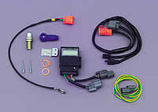

Pico Technologies makes an oscilloscope interface system that connects to a PC and can accept a Honda style detonation probe, or one of the Delphi Intellek Flat response probes.

As detonation generates an audible sound, it can easily be detected by isolating the signal.

As detonation generates an audible sound, it can easily be detected by isolating the signal.  The chart to the right illustrates the characteristic sound generated by detonation. | 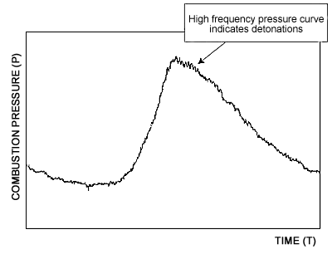

Detonation Signal on Oscilloscope | 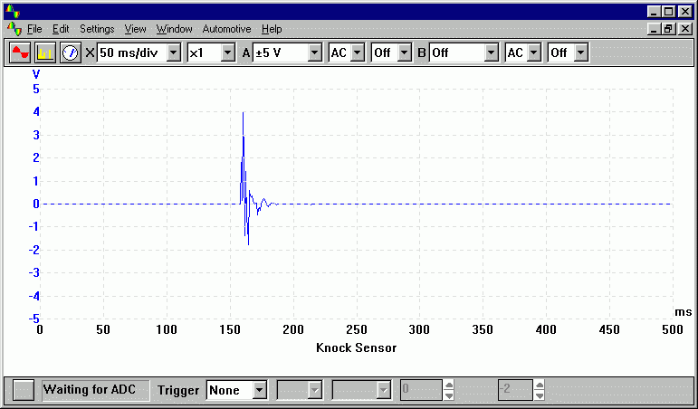

It is also possible to build a simple signal analyzer with under $100 of electronics that can interface to a Mychron Channel to detect detonation.

